**DAY-10-MONISHA SQL**

* **CREATE DATABASE:**

CREATE DATABASE company_db;

USE company_db;

* **CREATE TABLE MAJORS AND STAFFS**:
* create table majors (

dept_id INT PRIMARY KEY,

dept_name VARCHAR(50),

location VARCHAR(50)

);

* create table staffs (

emp_id INT PRIMARY KEY,

name VARCHAR(50),

age INT,

gender CHAR(1),

Salary DECIMAL(10,2),

dept_id INT,

hire_date date,

FOREIGN KEY (dept_id) REFERENCES majors (dept_id)

);

* **INSERT TABLES**:

INSERT INTO majors (dept_id,dept_name,location)

VALUES(1,'HR','Trichy'),

(2,'IT','Salem'),

(3,'Marketing','Erode');

**SELECT * FROM majors;**

INSERT INTO staffs (emp_id, name, age, gender, salary, dept_id, hire_date)

VALUES

(101, 'Mothis', 20, 'M', 45000, 2, '2022-05-10'),

(102, 'Senthil', 32, 'M', 50000, 1, '2022-06-06'),

(103, 'Monisha', 28, 'F', 48000, 2, '2022-10-17'),

(104, 'Abisha', 25, 'F', 72000, 3, '2022-11-21'),

(105, 'Tamilarasan', 24, 'F', 67000, 1, '2022-07-02'),

(106, 'Prathisha', 24, 'F', 35000, 3, '2022-08-05'),

(107, 'Lokamithra', 28, 'F', 56000, 2, '2022-12-08');

SELECT * FROM staffs;

* RESULT:

SELECT * FROM majors;

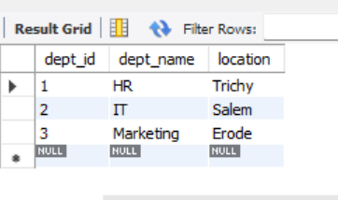

**SELECT * FROM staffs;**

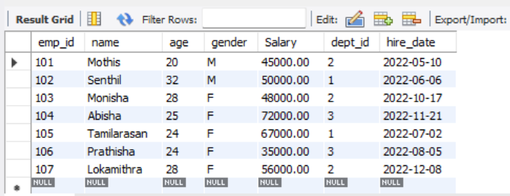

# **PROJCET QUESTIONS:-**

1. **FIND THE YOUNGEST EMPLOYEE IN THE COMPANY?**

SELECT *

FROM employees

WHERE age = (SELECT MIN(age) FROM employees);

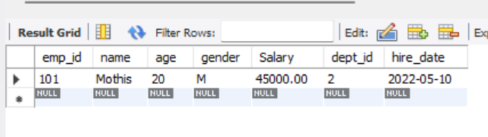

**2)COUNT HOW MANY EMPLOYEE ARE IN THE EACH DEPARTMENT?**

SELECT

d.dept_name,

COUNT(e.emp_id) AS total_staffs

FROM staffs e

JOIN majors d

ON e.dept_id = d.dept_id

GROUP BY d.dept_name

ORDER BY total_staffs DESC;

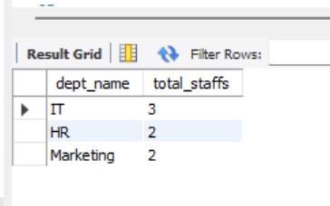

**3)SHOW ONLY FEMALE EMPLOYEE WITH SALARY ABOVE RS.45,000?**

select * from staffs where gender='f' and salary > 45000;

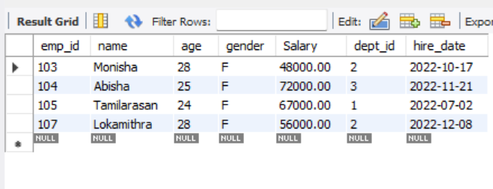

**Sample Mini-Projects Project**

**1: Basic Employee Management System**

**Objective: Simulate a simple employee database and perform basic CRUD operations.**

**1)Create a table**

CREATE TABLE employees (

id INT,

name VARCHAR(50),

department VARCHAR(50),

salary DECIMAL(10,2)

);



**2)Insert into table**

INSERT INTO employees (id, name, department, salary) VALUES

(1, 'Alice','Engineering', 70000),

(2, 'Bob','Marketing', 60000);



**3)SELECT: Retrieve all new data in employees record**

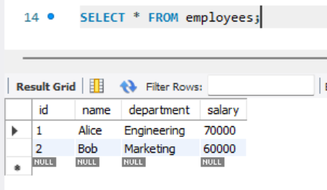

**4)UPDATE:**

UPDATE employees SET salary = 75000;



* **Verify Update data successfully:**

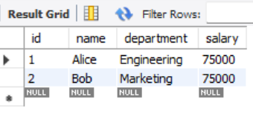

**5)DELETE AND VIEW TABLE:**

DELETE FROM employees WHERE name = 'Bob';



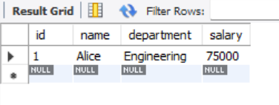

**Project 2**

**Sales Data Querying**

**Objective: Query and filter sales data from a table to answer specific business questions.**

**1)Create Table:**

create table sale (

order_id int,

product varchar(50),

quantity int,

price decimal(10,2),

region varchar(50));



**2)Insert Table:**

INSERT INTO sales (order_id, product, quantity, price, region)

VALUES

(1, 'Laptop', 3, 50000, 'East'),

(2, 'Mouse', 10, 800, 'West'),

(3, 'Laptop', 2, 52000, 'East'),

(4, 'Keyboard', 6, 1500, 'East'),

(5, 'Monitor', 4, 12000, 'North'),

(6, 'Mouse', 8, 900, 'East');

SELECT * FROM sale;

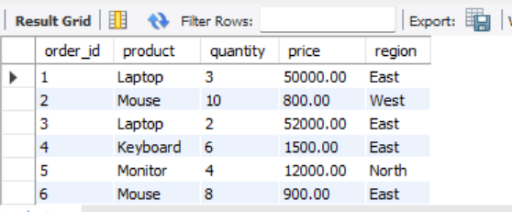

**3)Total Revenue from sales:**

SELECT SUM(quantity * price) AS total_revenue FROM sales;

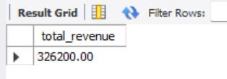

**4)Find all sales in the 'East' region that had a quantity greater than 5, and order them by price in descending order.**

SELECT *

FROM sales

WHERE region = 'East' AND quantity > 5

ORDER BY price DESC;

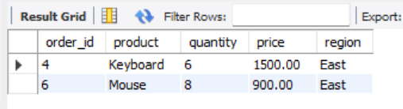

**5)Find the average price of sales for each product:**

SELECT product, AVG(price) FROM sales GROUP BY product;

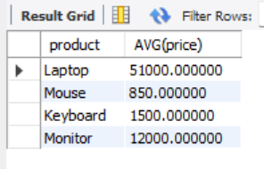

**Mini project-2**

**Customer Segmentation**

**Objective: Find the top 5 customers by total spending**

**1)Create Table:**

CREATE TABLE sales (

order_id INT PRIMARY KEY,

customer_name VARCHAR(50),

product VARCHAR(50),

quantity INT,

price DECIMAL(10,2)

);

**2)Insert Table:**

INSERT INTO sales (order_id, customer_name, product, quantity, price)

VALUES

(1, 'Senthil', 'Laptop', 2, 70000),

(2, 'Monisha', 'Mobile', 3, 25000),

(3, 'Arjun', 'Laptop', 1, 72000),

(4, 'Monisha', 'Tablet', 2, 30000),

(5, 'Kavin', 'Mobile', 5, 26000),

(6, 'Priya', 'Laptop', 3, 72000),

(7, 'Arjun', 'Mobile', 4, 25000);

**View Table:**

SELECT * FROM sales;

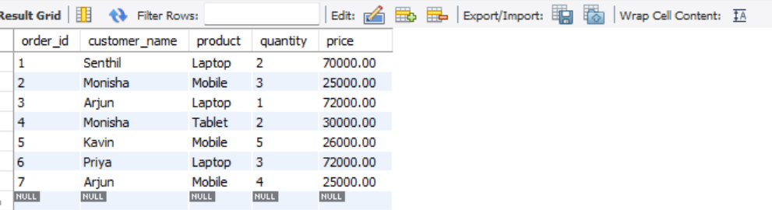

### **3)Group by Customer and Calculate Total Spending**

SELECT

customer_name,

SUM(quantity * price) AS total_spending

FROM sales

GROUP BY customer_name

ORDER BY total_spending DESC

LIMIT 5;

